**Contents**

Acknowledgement 2

Abstract: 3

Introduction: 4

Purpose of Report: 4

Background: 4

Objectives 5

Project Objectives: 5

Academic Objectives 6

Features: 7

System Block Diagram 9

Feasibility Analysis: 10

Operational Feasibility: 10

Technical Feasibility: 10

Schedule Feasibility: 10

Cost Feasibility: 10

I/O system requirement 11

The inputs are: 11

The Output will be: 11

Data storage 11

Conclusion: 12

Further Recommendations: 12

Screen shots 13

# Acknowledgement

This report has been prepared to describe on the project entitled “Smart Home” as a candidate for Locus 2014 Thematic Software Competition. We express our deep gratitude to the Locus Committee, for providing us the platform to present our knowledge. We would also like to thank all the teachers who have directly or indirectly assisted us in our project.

This project is intended to bridge our class study with the real engineering industry. This has been an excellent opportunity to extend our knowledge and understanding beyond books to understand real life use of technology.

Also, we would like to express our sincere thanks to all the people who have assisted us in preparation of this report. Last but not the least; we would like to thank our friends for the continuous support and moral encouragement.

# Abstract:

Software has become an essential part of human life. It can be implemented in every possible work possibility scenarios. The complexity of the work which was to be handled by human brain is accomplished by the use of a software system.

The project that has been proposed is entitled ‘Smart Home’. This project aims to develop a system that is capable of controlling various electronic devices connected to the system. The controlling however, is synced and maintained via a central syncing server, accessible from web via an easy to use interface. For offline usage a sms based system remains stand by. The house, however can be interacted via the use of voice commands also.

The system has been designed in such a way that it is completely extensible. The extensions are the plugins that can be designed as per the requirement. The other important feature of this system is that it can learn the user’s usage behavior and can recommend appropriate measures. The system is even capable of giving snapshots from the home as required by the user. The system has the capacity to respond to the user’s query via voice to using Text to speech engine embedded in the system.

The project that has been developed supports multi-platform, supports scheduling operations, can be deployed offline usage via SMS, power usage analysis, etc. The project is distributed deployable. It allows for easy use of preexisting infrastructures for the implementation purpose. The advantage of this type of system would be automated home appliances control, easy to access features, extending the functionality as per the requirement, etc.

The software, that has been developed has been planned to be a freeware, and the only cost for the system is the hardware which is about $30.

# Introduction:

## Purpose of Report:

The system we have developed is ‘GHAR’, a Home Automation System

The purpose of this report is basically to give an insight into the system that we have built as an entry in the Locus 2014 Thematic Software Competition.

## Background:

As we know, that all the electronic appliances, though smart, depend on in one way or the other on dumb switches and plugs. Often the switches can be mistakenly left open, thereby increasing the chance of big electricity bills or even life threatening hazards. The problem now arises that the person in charge has no way to control the home appliances remotely.

The easy solution is to allow computers to perform the controlling operations. The system should be able to be controlled offline too in the case of internet service outage.

The solution we are providing is the same. We, provide efficient use of various hardware and software algorithms to ease the scheduling process. The person using the software for will simply need to choose the method of control. The voice based home server can aid in easy controlling and information providing application.

# Objectives

## Project Objectives:

The major objective for this project is to design a ‘Home of the Future’, implementing not just a basic command based home but an intelligent system.

Thus the basic objectives of our project are as follows:

1. To enable remote controlling of electronic equipment’s connected to the system.
2. To enable offline administration of the system based on SMS.
3. To enable speech controlled home automation.
4. To enable speech based out.
5. To implement a plugin extensible system.
6. To learn the user’s usage behavior and recommend appropriate measures.
7. To allow various preferences as the constraints.
8. Represent and provide data in handy format.
9. To allow easy addition/deletion of devices connected to the Smart Home System.
10. To allow easy scheduling operations.

## Academic Objectives

In terms of academic level this project helps us learn more on web terminologies and web development. Because of this project work we were able to learn about server side scripting language like PHP, scripting language as Python, and GUI designing using Qt Framework. This project also helped us in knowing about various data passing and parsing techniques. Beside these we came to obtain a new level of academic step learning about networking concepts, distributed network architectures, database management and querying using MySQL, studying requirements of user from the system, integrating SMS System and basics of Artificial Intelligence. In brief the the following are major academic objective of this report concerning the system has the following credentials:-

1. To help us get an insight into software engineering process.
2. To understand more on user and system requirements.
3. To help us analyze the functional and non-functional requirements.
4. To learn about risk analysis and its management.
5. To identify constraints and their implementations during software design.

# Features:

For, the first phase, we have included a few sufficient features in our project which are as follows:

1. **Multi-Platform Support:**

Our application supports multiple platforms. It will be compiled for Linux, Windows with further extension to Mac OS X.

1. **Web Based Home Remote Controlling:**

Our application supports remote controlling of the switches connected to the system via an easy to use web based interface.

1. **SMS Based Offline Home Remote Controlling:**

Our application supports SMS based remote controlling of the switches connected to the system via special SMS commands.

1. **Voice Based Commanding:**

Our application supports numerous pre-defined voice commands. This allows for easy switching as well as information gathering purposes.

1. **Scheduled Operations:**

Our system supports scheduled operations also that occur at regular intervals. This is taken care by the server.

1. **Power Analysis and Recommendation:**

Our system is able to keep track of power spent on a daily basis. Based on large data to be recorded with time, the system can analyze the devices which require more power and can sort them accordingly. The system can then provide appropriate recommendation for the same.

1. **Easy to Use Responsive Web Based UI**

The system can easily be controlled via an easy to use theme which is completely responsive and can run in all devices.

1. **Multiple Devices Support**

Based on the hardware present, one can easily add and delete devices as per the requirement of the user.

1. **Easy to Use Android App:**

The controlling can also be obtained through the available android app.

1. **Intruder Detection**

The system has built in support for intruder detection. Based on Webcam the system can record unwanted motion in the surrounding and can also send SMS to the saved numbers on such anomaly.

1. **Face Recognition**

The system has built in support for facial recognition to facilitate recognizing people at the door and/or in any other desired location. The faces, if recognized will be prompted to the user via the speech engine.

1. **Weather Description**

The system has capability to parse the weather data for a specified location. The parsed weather data can be accessed via the home server. A voice based control is also available if required.

The addition of these facilities mark completion of the project. However, if time permits, we could include other features also.

# System Block Diagram

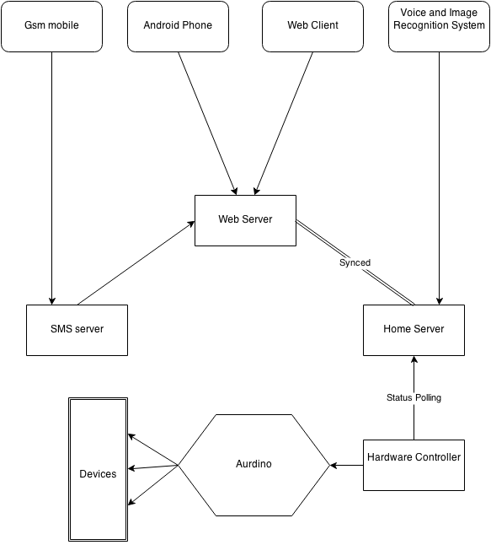

# Feasibility Analysis:

### Operational Feasibility:

The system we are trying to implement is mostly automated. So, the end user will save himself/herself from a lot of trouble. As we are providing a faster approach a simple training session will be sufficient for the end user to work in the system. Thus the project seems operationally feasible as end user is likely to save a lot of time and effort by the use of our software.

Hence our solution seems operationally feasible.

### Technical Feasibility:

Our project mainly requires expertise in Python, Django, C ,SQL. We have our team with experience in the above mentioned topics. The hardware also can be constructed cheaply and easily. Hence the project is technically feasible.

The algorithms mentioned has been applied and implemented to work in feasible time.

### Schedule Feasibility:

The project needs some configurations to work upon. Thus, for this purpose, we would require about 1 month to collect necessary data. However for the sake of demonstration we have used dummy data for the same.

Hence, for a given time it seems feasible.

### Cost Feasibility:

This solution is cost feasible as the software components will be given as freeware with open hardware schematics.

Hence in about $30, this project is cost feasible.

# I/O system requirement

The prime objective of this project is implement a basic home automation system. Thus its function will be alike to that of the present case. But irrespective of its prime objective, this can be used in any conditions where switching operations are required.

## The inputs are:

-Hardware ID and Name

-On/Off Commands

-Add/Delete Commands for processing

-SMS

-Voice

-Meter Readings

-Schedule

## The Output will be:

**-**Tabular view of the devices with controlling UI.

-Power Consumption Chart

-Controlled Hardware

## Data storage

-Use of Relational Database model

-Use of embedded SQLite database engine

-Various tables with relational mapping

-Syncing among database in regular intervals.

# Conclusion:

Hence, by implementing a basic hardware system controlled by distributed software system, online and offline via Web, SMS, Voice, the completion of the project can be marked. The system even implemented an extensible approach, with other features as voice interacting home unit, intruder detection, face recognition, etc.

# Further Recommendations:

Though, many important features has been implemented for the first phase, the following are some improvements that has been considered productive:

1. Controlling via Infra-red, the appliances.
2. Live Stream available on request from the user.
3. Power level control for appliances.
4. Learning of user’s general usage behavior.
5. Multi-Language Support
6. More Natural Feedback
7. Natural Language Processing for Queries

# Screen shots

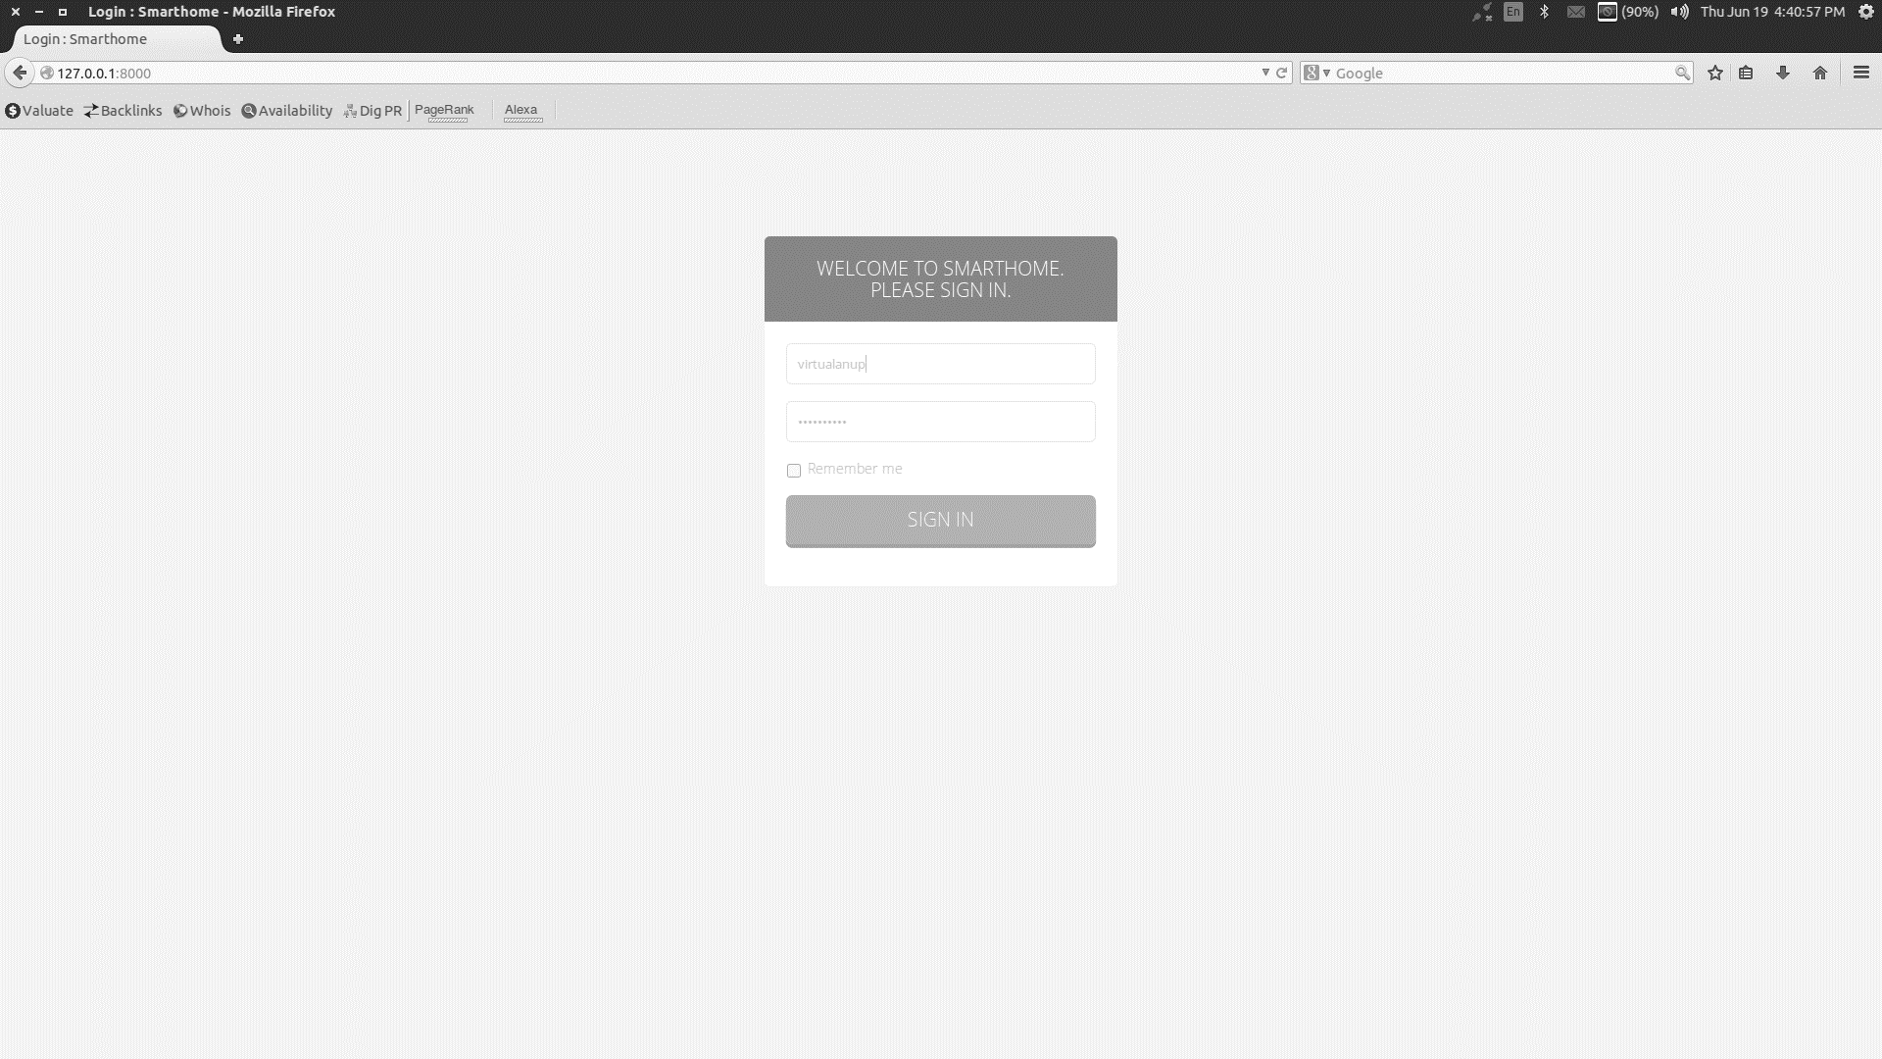

Fig: Login Screen

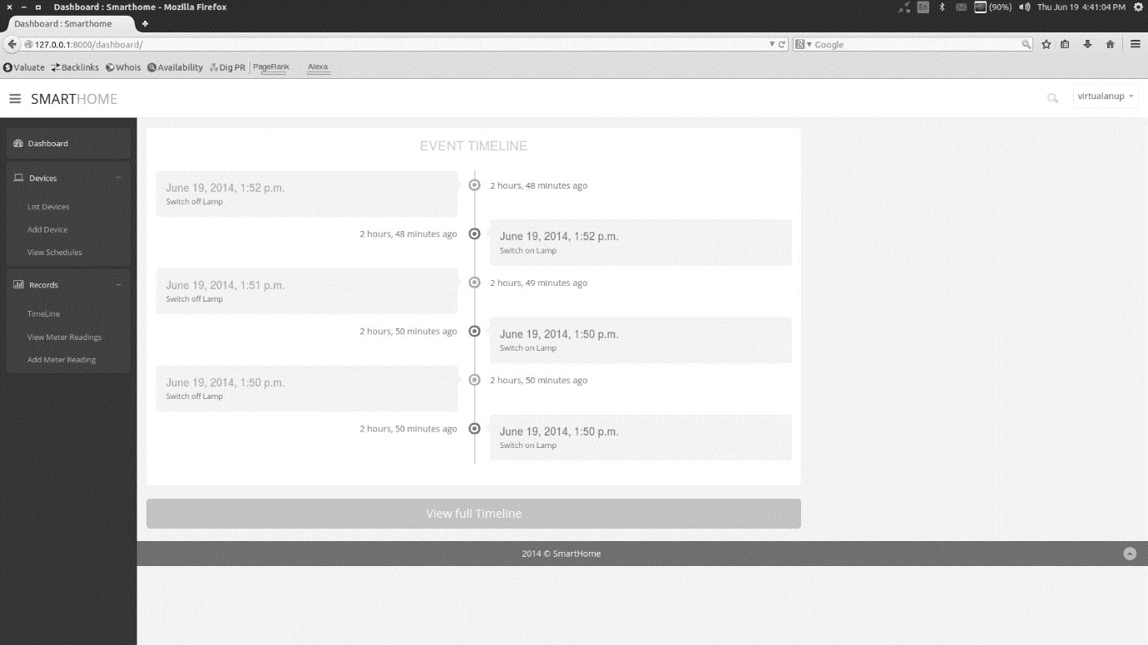

Fig: Admin Dashboard

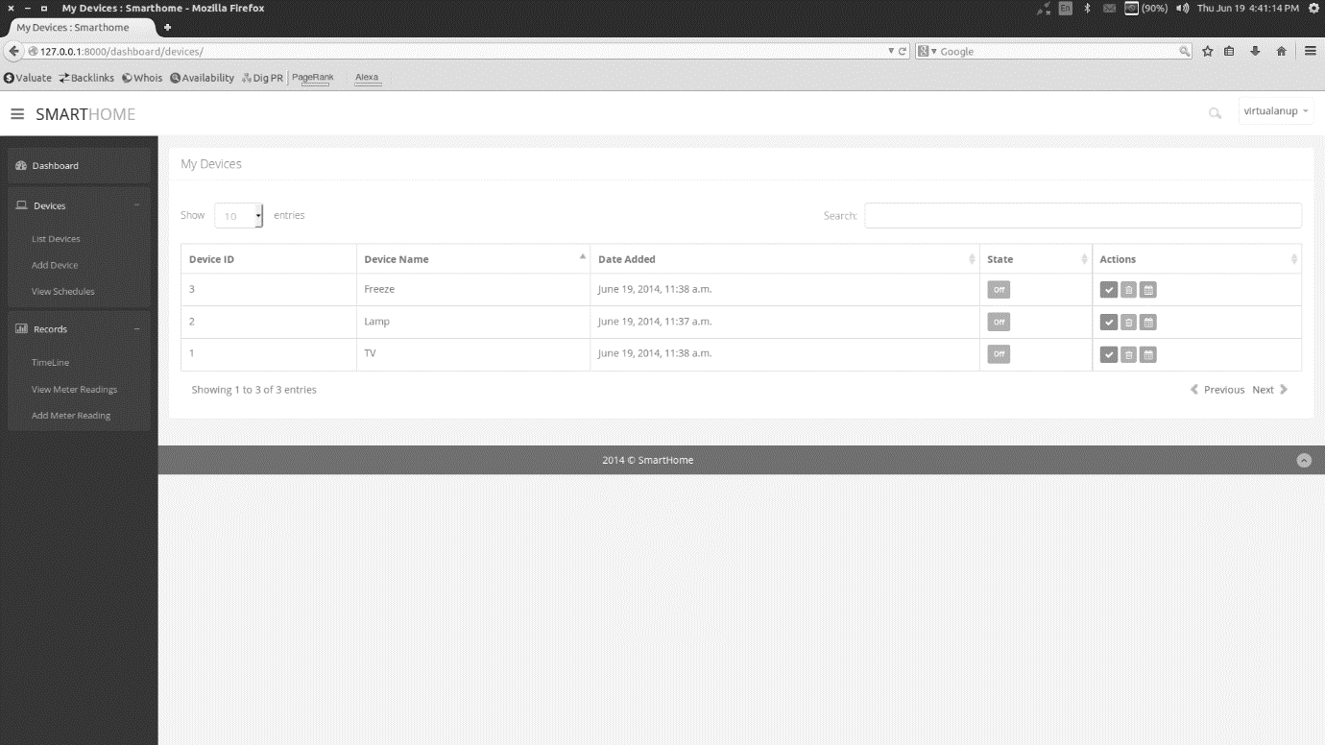

Fig: Devices Control

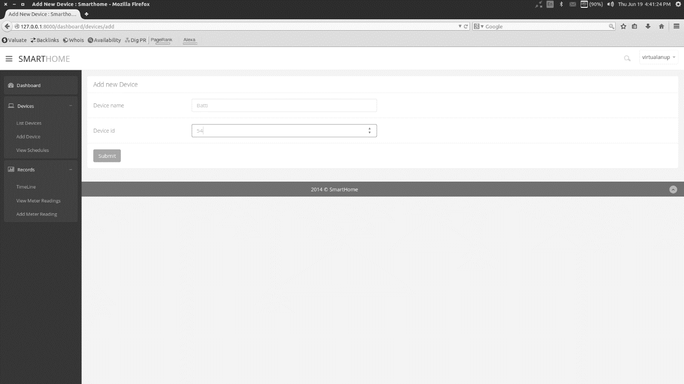

Fig: Devices configuration